WEST CHILTINGTON NEIGHBOURHOOD PLAN COUNCIL

SUSTAINABILITY APPRAISAL SCOPING REPORT

Chapter 1 – Introduction and methodology

Introduction

This is the scoping report for a sustainability appraisal in respect of the Neighbourhood Development Plan (NDP) for the parish of West Chiltington which is designed to fulfil the requirements of the Environmental Assessment of Plans and Programmes Regulations 2004, European Union Directive 2001/42/EC (the SEA Directive) and the Equality Act 2010.

A NDP is in the course of preparation by the West Chiltington Neighbourhood Plan Council (WCNPC) that was established in September 2013 as a result of a decision of the West Chiltington Parish Council to prepare a NDP. The WCNPC comprises volunteer residents of the parish and parish councillors. The Neighbourhood Area was designated by Horsham District Council after consulting the South Downs National Park Authority on 25 February 2013.

The West Chiltington NDP covers an area that extends 6 miles north to south and an average of 1 mile east to west and is located towards the southern end of Horsham District in the County of West Sussex. It comprises two settlements West Chiltington Village and West Chiltington Common which are approximately one mile apart with more isolated communities in Gay Street to the west and Broadford Bridge in the north. Apart from about 3 houses to the very north it lies between, although not immediately adjacent to the A272 to the north, the A24 to the east, the A283 to the south and the A29 to the west. Its principal neighbours are Pulborough to the west and Storrington to the south with Horsham and Worthing as the main towns providing services for residents. Chichester is also a significant source of services but is 20 miles distant.

The two settlements are to the south of the parish and the major undeveloped part is agricultural/horticultural land with isolated developments along the roads. The parish has evidence of prehistoric, Roman and Saxon foundations and has a Norman church. The parish is primarily residential and agricultural with very limited local businesses. The current population is roughly 3500 A very small area to the south falls within the South Downs National Park but it is tiny and comprises part of a small number of back gardens and some woodland In relation to the parish as a whole and to any issues that the NDP might be concerned with it is totally insignificant. In the woodland there is also a Site of Special Scientific Interest and a Site of Nature Conservation Interest.

A map of the area is shown in Fig. 1.

Fig. 1 Map of West Chiltington Parish Neighbourhood Area
Neighbourhood Development Plan content

The NDP will cover the following areas:

- Introduction to Neighbourhood Planning
- Issues and objectives
- Development proposals and maps
- Policies
- Non statutory policies and action plan
- Monitoring and delivery

The issues, objectives and policies will be based upon seven activities relevant to the parish and consistent with the draft Horsham District Council Planning Framework 2014 and other Local Plans.

- Economic activity – business
- Housing and the built environment
- Transport and infrastructure
- The natural environment
- Sport, recreation and community
- Health and well being
- Mineral extraction

The objectives of the plan will be:

- To improve opportunities for local people to live and work in the parish
- To improve conditions for local businesses to be successful
- To develop homes for local residents that meet the local housing needs and are consistent with the planning policies for rural settlements in the Horsham District Planning Framework 2014
- To prioritise development in favour of affordable homes for rent/shared equity, to enable older residents to downsize and to the extent that market conditions will allow encourage young families into the parish
- To provide safe transport routes through the parish
- To improve and maintain public rights of way
- To ensure that future development recognises existing pressures on road network
- To increase the coverage of high speed broadband and mobile communication
- To improve drainage at surface water flooding points
- To conserve and enhance the local natural environment
- To improve facilities available to children and young people
- To expand activities to the very old and disabled members of the community
- To improve access to health care services
- To accept some conventional drilling for gas at Broadford Bridge and ensure that any proposals for unconventional drilling are subject to full local consultation

Stages in development and processing of Neighbourhood Development Plan and Sustainability Appraisal

The West Chiltington NDP Council started its planning process in September 2013 with a brainstorm to identify the issues that it felt the plan was likely to cover. It decided upon the seven activities listed above and proceeded to commission a Housing Needs Survey, a Business Survey and a number of working groups to consult on the issues within each activity taking account of the economic, environmental and social conditions pertinent to the Parish. The working groups reported to the Plan Council and objectives and policies were developed and exposed to public consultation in meetings and at the Village Show and further developed through the use of questionnaires and a feedback email service.

In order to preserve the special nature and character of the area an historic policy designated the settlements as places where development was limited to circumstances in which there was a specific local need eg for affordable homes or for downsizing only very small scale development has taken place in recent years. The adopted policies of the Core Strategy 2007 and the General Development Control Polices 2007 and the emerging policies in the Horsham District Council Planning Framework preserved the same principles and so future development was never expected to be significant. As the Neighbourhood Plan developed it was clear that there was very little scope for economic development as the area is primarily residential and there was no intention to have any development in the conservation area or the protected areas of the natural environment and countryside. In identifying potential sites for development a sustainability template was employed in the site assessments to ensure that sustainability was properly addressed.

Format of scoping report

The remainder of the report will be in this format:

Chapter 2 describes the policy context (Schedule 2(a) and (e) of the Environmental Assessment of Plans and Programmes Regulations 2004)

Chapter 3 describes the key sustainability issues

Chapter 4 describes the proposed next steps

Chapter 2 – Policy context (Task A1)

There was general awareness that the Localism Act 2011 had introduced neighbourhood planning into the planning process as part of the coalition government’s policies of reform, encouraging development and giving local people more of a say in the way in which their communities moved forward. The process began by looking at Horsham District Council’s guidance on Neighbourhood Plans in its Members’ Update 261 of September 2013 and the Quick Guide to Neighbourhood Plans available from www.locality.co.uk. Two or three approved plans were also available for background reading

Policy issues

More research into the policy context identified the following as relevant to the work that the WCNPC had to do. The adopted Development Plan consisting of the Core Strategy and General Development Control Policies 2007 is the main policy but the Horsham District Planning Framework (HDPF) is in the course of a public examination by a Planning Inspector and has been used in this report as the most relevant policy document for assessing the impact of the Neighbourhood Plan because it is forward looking. Should the Planning Framework not be adopted or be amended in any significant respect before the Neighbourhood Plan is made then appropriate amendments will need to be to reflect the current adopted development plan or amended framework.

As well as identifying the HDPF as a whole as a relevant policy the specific policies relevant to a rural community have been identified in order to ensure that in developing the NDP and the SA/SEA the specific requirements of the individual policies are taken on board.

Core policy strategy | What the policy says | Impact on Neighbourhood Plan
Localism Act 2011 | Provides for local bodies to prepare Neighbourhood Development plans that conform to certain basic conditions | The WCNPC has agreed its Neighbourhood Area and drafted its plan to meet the basic conditions
Neighbourhood Planning Regulations 2012 | Provides the legal framework for the preparation of neighbourhood development plans | The WCNPC needs to satisfy the regulations when developing its plan
National Planning Policy Framework 2012 | Provides the national framework within which all planning has to be conducted | Sets the framework for local (ie district level) plans and NDPs with which they have to be compliant including the requirement for sustainability and these requirements have been taken into account in developing the plan
Horsham adopted Core Strategy 2007 and General Development Control Policies 2007 | Provides the current planning framework for Horsham District | If the HDPF currently subject to public examination does not become the new planning policy the NDP will need to be in general conformity to the current adopted policies.
Horsham District Planning Framework 2014 | In compliance with the HDCPF for the local planning authority to define how it will deliver sustainable development and in which it sets out its detailed policies for delivering its target of new homes and contributing to economic and social policies | The NDP has to be in general conformity with the HDPF
South Downs National Park Authority development plan | SDNPA is a planning authority for part of the Horsham District and the plan sets out its policies | A small amount of the Neighbourhood area falls within the SDNP
Habitats Directive Council Directive 92/43/EEC of 21 May 1992 | European Sites are to be protected by assessments of plans. Natural England is the competent authority. | Screening for HRA to be undertaken and an assessment made if necessary
Specific policies from HDPF
Sustainability policies 1-3 | The HDCPF promotes the principle of sustainable development that allows for organic growth in rural areas maintaining the existing settlement pattern and limiting development principally to the edges of the existing built up areas. Preventing the merger of settlements and protecting the nature and character of the rural landscape are key principles.  The policies support the need to provide affordable homes in the rural community and establish a settlement hierarchy that recognises the nature and character of small rural settlements with heritage assets and valuable landscape features. | Promoting sustainable development is a sine qua non of any planning activity and will be a key principle of the NDP. The policies will be applied to West Chiltington through recommending appropriate development that supports local needs.  Development priority will be given to affordable homes as this is the primary local need.
Settlement expansion policy 4 | The growth of settlements across the District will continue to be supported in order to meet identified local housing, employment and community needs. Outside built-up area boundaries, the expansion of settlements will be supported where specific conditions are satisfied | In identifying sites for development the NDP will need to ensure that its proposals are in general conformity with the principle of the policy and the conditions for support.
Rural Economic Development (Policy 9) | Sustainable rural economic development and enterprise within the District will be encouraged in order to generate local employment opportunities and economic, social and environmental benefits for local communities | There are few opportunities for economic development in West Chiltington but if suitable land is available some contribution can be made in the NDP subject to maintaining the nature and character of the area
Housing Provision (Policy 14) | The policy establishes a target of 1500 homes from Neighbourhood Plans. | There is no specific target for West Chiltington but its plan will make an appropriate contribution
Meeting Local Housing Needs (Policy 15) as likely to be amended by Government announcement of 28 November 2014 in relation to small sites | Housing provision will be based primarily upon local needs with affordable housing being achieved through a specific policy for developments of 5+ dwellings  Developments of 15+ must have 35% affordable  Developments of 5-14 must have 20% affordable  NB The lower limit might be amended in light of Government policy on small developments to 10-14. | Local need has long been a principle espoused in West Chiltington and the NDP proposals will need to continue this and reflect the quotas of affordable homes in identifying sites and assessing need.
.Rural exception sites (Policy 16) | The policy allows developments on green field sites based on local need – exception sites | It is not envisaged that West Chiltington will have any exception sites
.Retirement housing (Policy 17) | Encourages development of retirement housing | Downsizing for older residents has been a feature of the area’s housing need and will be considered for the NDP although market conditions make it challenging to achieve
Environment Policies  Protection of rural character (Policy 24) | Supports proposals that conserve the landscape and settlement characteristics from inappropriate development  Ensuring that there is no adverse impact on the natural beauty of the area and on protected environments from nearby development | The NDP will make modest proposals for development that are in general conformity with these principles and further develop its existing commitment to the natural environment and biodiversity.
Countryside protection (Policy 25) | Supports proposals for countryside protection that meet the needs of agriculture and horticulture, mineral extraction and recreational use or which enable the sustainable development of rural areas | The NDP will make modest proposals for development that are in general conformity with these principles and further develop its existing commitment to the natural environment and biodiversity.
Settlement coalescence (Policy 26) | Allows developments between settlements that do not reduce the openness of gaps, create urbanization or which contribute to the conservation, enhancement or amenity of the countryside. | The NDP will make modest proposals for development that are in general conformity with these principles and further develop its existing commitment to the natural environment and biodiversity.
Replacement dwellings and house extensions in the countryside (Policy 27) | Support will be given to replacements and extensions within the curtilage of dwellings outside the built environment if they are in scale and character with the existing building(s) | The NDP will make modest proposals for development that are in general conformity with these principles and further develop its existing commitment to the natural environment and biodiversity.
Protected landscapes (Policy 29) | Developments in the South Downs National Park will need to demonstrate how they contribute to protecting the landscape and maintaining the character of the national park | The NDP will make modest proposals for development that are in general conformity with these principles and further develop its existing commitment to the natural environment and biodiversity.
Green infrastructure and biodiversity (Policy 30) | Developments will be supported that maintain green infrastructure and biodiversity | The NDP will make modest proposals for development that are in general conformity with these principles and further develop its existing commitment to the natural environment and biodiversity.
Quality of new development (Policy 31) | High quality and inclusive design for all development in the District will be required based on a clear understanding of the local, physical, social, economic, environmental and policy context for development | The NDP will make modest proposals for development that are in general conformity with these principles and further develop its existing commitment to the natural environment and biodiversity.
Development principles (Policy 32) | Developments will be required to make efficient use of land, be designed not to adversely affect existing neighbours, be of an appropriate scale, be locally distinctive and respect local design criteria | The NDP will make modest proposals for development that are in general conformity with these principles and further develop its existing commitment to the natural environment and biodiversity.
Cultural and heritage assets (Policy 33) | The historic environment will be sustained and enhanced | The NDP will make modest proposals for development that are in general conformity with these principles and further develop its existing commitment to the natural environment and biodiversity.
Flooding (Policy 37) | Development proposals will follow a sequential approach to flood risk management, giving priority to development sites with the lowest risk of flooding and making required development safe without increasing flood risk elsewhere | Surface water flooding is an issue and will be addressed in the NDP
Strategic Policy 38  Infrastructure provision | The release of land for development will be dependent on there being sufficient capacity in the existing local infrastructure to meet the additional requirements arising from new development, or suitable necessary mitigation arrangements for the improvement of the infrastructure, services and community facilities caused by the development being provided. | With limited and difficult road infrastructure in the area any development is likely to have some adverse impact and this will need to be taken into account in any NDP proposals and in assessing any potential development sites
Sustainable Transport (Policy 39) | There is commitment to developing an integrated community connected by a sustainable transport system | Improving transport links and services will be an element in the NDP
Inclusive communities (Policy 41) | Positive measures which help create a socially inclusive and adaptable environment for a range of occupiers and users to meet their long term needs will be encouraged and supported. | The rather skewed demographics of the area make this a key feature of the community’s interest and the NDP will deal with any deficiencies
Community facilities, leisure and recreation (Policy 42) | The provision of new or improved community facilities or services will be supported, particularly where they meet the identified needs of local communities, or contribute to the provision of Green Infrastructure | Existing facilities are generally good but any deficiencies will be addressed in the NDP

Baseline data (Task A2)

The baseline data for the West Chiltington Neighbourhood Area can be stated as follows.

Location

The map in Fig 1 (above) shows the Neighbourhood Area with the boundaries defined and the settlements conventionally depicted. The structure of the built up areas, boundaries and landscape has the following features. To the south the built environment is close to the parish boundary which abuts the South Downs National Park (SDNP), a Site of Special Scientific Interest (SSSI), the River Chilt flood plain and the separation zone between West Chiltington and Storrington. To the west the built environment is bounded by agricultural land. To the north of The Common there is the separation zone to the Village and to the north of that is the principal agricultural zone that forms a large part of the parish area. To the east the built environment is close to the separation zone with Thakeham.

Natural environment

West Chiltington lies in a strategic location between the South Downs National Park and the High Weald Area of Outstanding Natural Beauty, considered an area of international importance. The northern section of the parish is predominantly an agricultural area but the developed area includes both a Conservation Area in the Village and woodland and an SSSI in the southern regions. Areas of Ancient Woodland have also been discovered within the parish but mostly in its northern regions.

Significant sites include:

South Downs National Park (tiny amount included on southern boundary of parish)
Monkmead Woods
Hurston Warren SSSI
Site of Nature Conservation Interest in Monkmead Woods
Ancient woodlands – east of Gay Street and elsewhere to north of parish

The following map (Fig 2) illustrates the location and extent of the main open space at Monkmead Woods close to the built up area with its SSSI, proximity to the SDNP and the SNCI.

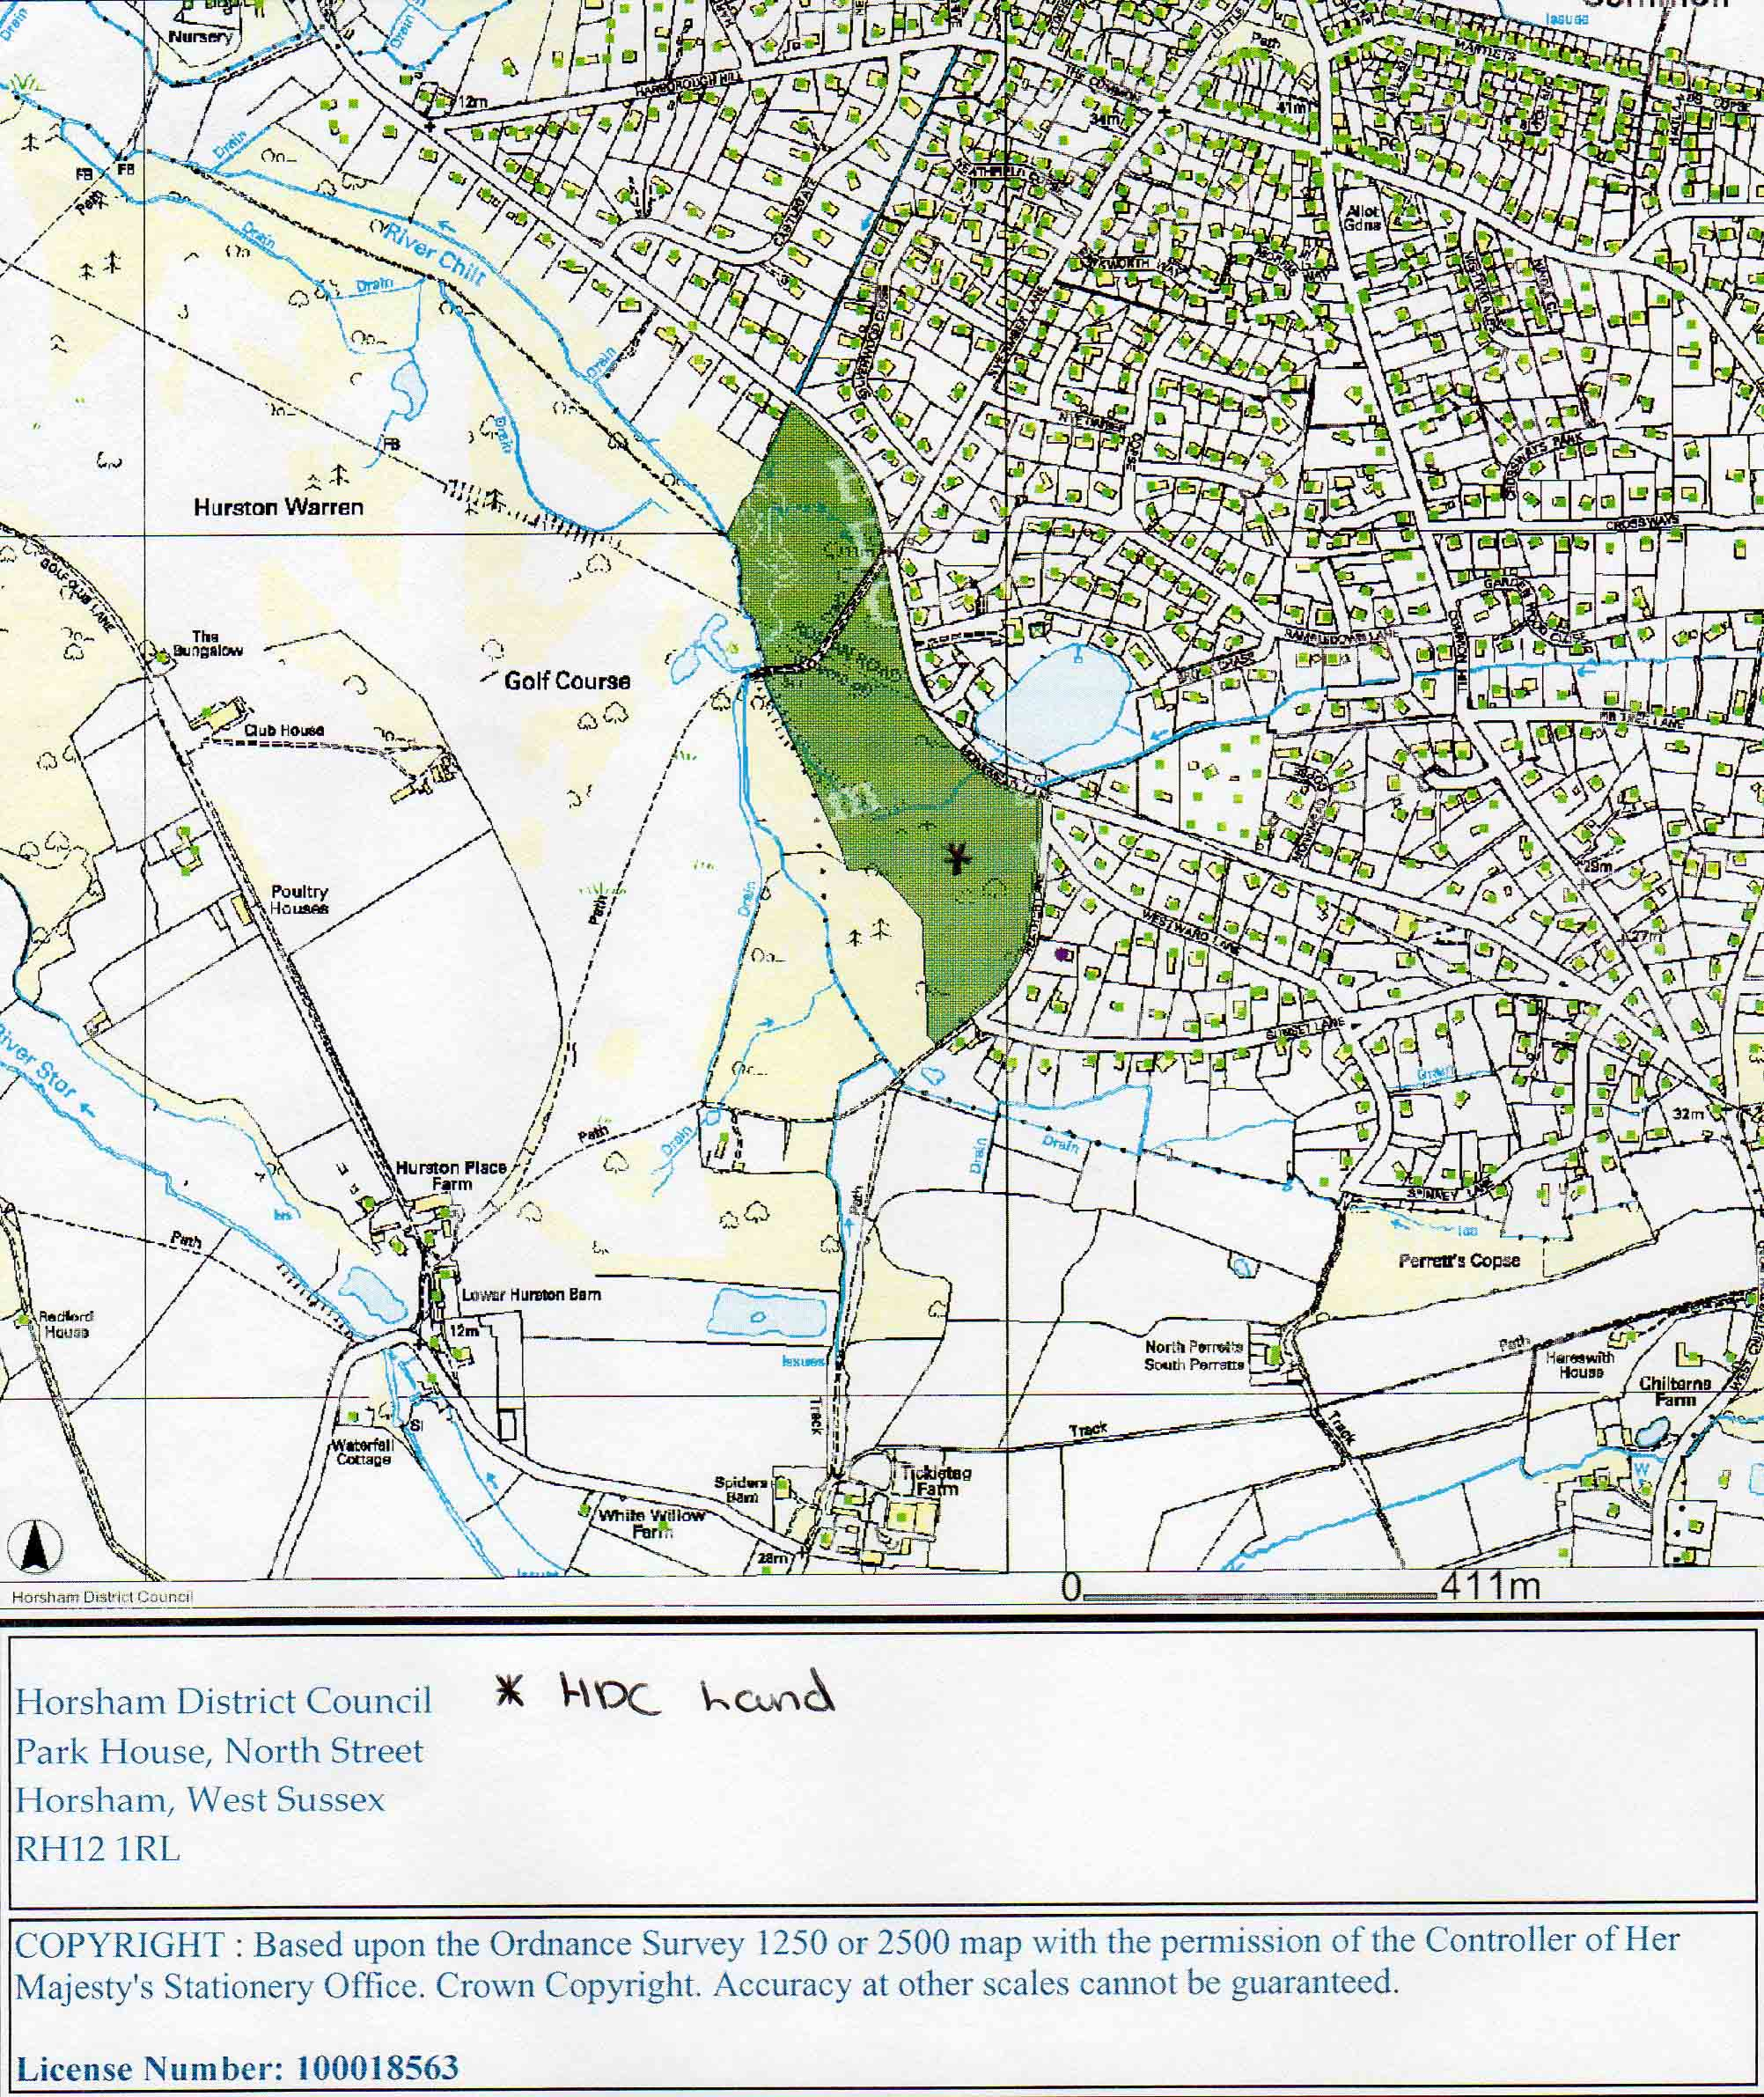

Fig 2: Monkmead Woods map
Landscape

Horsham District Council has carried out a Landscape Capacity Assessment 2014. The landscape is located in the Wealden Greensand National Landscape Areas. Within Horsham District, the landscape falls within character areas identified as F1, E1 and D1. Much of the landscape is characterised by sandstone ridges and river valleys. To the north of West Chiltington Common there are orchards and nurseries, with woodland, heathland and rough pasture further south between Storrington and West Chiltington Common. To the south of Storrington the landscape becomes more open, with views to the chalk escarpment to the south. Within all parts of this zone distinctive sunken lanes can be found winding through the landscape. There are gaps to prevent settlement coalescence between Storrington and The Common, between The Common and The Village and between West Chiltington and Thakeham.

There are some detailed assessments of three areas summarised in the tables in the Landscape Capability Assessment 2014:

- Local Landscape Character Area 53: Land south of Nutbourne and West Chiltington

.Assessment Summary Medium Scale Housing |  | Large Scale Housing |  | Large Scale Employment
Landscape Character Sensitivity | High |  | High |  | High
Visual Sensitivity | Low-moderate |  | Low-moderate |  | Moderate
Combined Landscape Sensitivity | High |  | High |  | High
Landscape Value | Moderate |  | Moderate |  | Moderate
OVERALL LANDSCAPE CAPACITY | No/Low |  | No/Low |  | No/Low

- Local Landscape Character Area 54: Land South and South East of West Chiltington Common

Assessment Summary Medium Scale Housing |  | Large Scale Housing |  | Large Scale Employment
Landscape Character Sensitivity | High |  | High |  | High
Visual Sensitivity | High |  | High |  | High
Combined Landscape Sensitivity | High |  | High |  | High
Landscape Value | Moderate |  | Moderate |  | Moderate
OVERALL LANDSCAPE CAPACITY | No/Low |  | No/Low |  | No/Low
- West Chiltington Village

Assessment Summary Small Scale Housing
Landscape Character Sensitivity | Low-Moderate
Visual Sensitivity | Moderate
Combined Landscape Sensitivity | Low-Moderate
Landscape Value | Moderate
OVERALL LANDSCAPE CAPACITY | Moderate-High

The studies show that the most viable area for development without significant impact on the landscape is around the village. The capacity is for small scale development which is defined as up to 100 homes although this maximum would be grossly excessive for any specific part of the landscape area affected and the associated infrastructure. Small scale development of up to 15 homes per site on a very small number of sites could be viable subject to other planning issues.

Housing

There are 1586 households in West Chiltington. Table 1 shows the distribution of houses by type.

Housing Type | District | Parish
Detached | 21,844 (38.6%) | 1,317 (85.2%)
Semi-detached | 14,985 (26.5%) | 161 (10.4%)
Terraced | 9,613 (17.0%) | 3 (0.2%)
Flat/Maisonette | 8,293 (14.7%) | 59 (3.8%)
Caravan or other temporary structure | 395 (0.7%) | 5 (0.3%)
Source Census 2011
Table 1
Table 2 shows the housing by type of tenure.

Tenure | District | Parish
Owner occupied | 40,926 (74.5%) | 1397 (90.4%)
Shared ownership | 363 (0.7%) | 3 (0.2%
Social rented | 6347 (11.6%) | 53 (3.4%)
Private rent | 6480 (11.6%) | 77 (5%)
Other | 807 (1.5%) | 15 (1%)
Source Census 2011
Table 2
Approximately 60% of the homes within the parish fall into the two highest Council Tax bands illustrating the high prices that land and homes command.

A Housing Needs Survey was conducted in 2014 that identified a need for affordable homes as the principal housing need in the parish.

Heritage

There are 67 Listed Buildings in West Chiltington of which the parish church is the only Grade I listed building with everything else being Grade II. Many of the buildings are in the West Chiltington Conservation Area. (CONARAWC001).

Leisure and recreation

There is a very extensive range of leisure activities available to residents of the parish with many based at the recreation ground close to the village hall but many others are carried on at the Church, the Church Hall, the Parish Reading Room, the Village Hall itself and the school, which are the principal community facilities in the parish. A former youth club building is now somewhat damaged by weather but consideration is being given to rebuilding it.

Infrastructure

Although bounded by major roads such as the A24, A29, A272 and A283 all of these are outside the parish boundaries. Roads into the parish include:

- Fryern Road from Storrington – a convoluted approach with a significant pinch point at the Roundabout Lane boundary.

- Monkmead Lane – the southern link road between the Storrington and Pulborough access routes – used as a rat run with a very awkward exit at the eastern end.
- West Chiltington Road from Pulborough – another convoluted approach with a significant pinch point just before the parish boundary.

- Harborough Hill – probably the best road in the parish leading to the crossroads.
- Common Hill – a convoluted road leading from the crossroads back to Storrington.

All other roads to the north and east such as The Hollows, East Street, Broadford Bridge Road, Haglands, Sinnocks, Southlands Lane, Smock Alley and Roundabout Lane are largely, if not actually, single track roads with passing places and include some old drovers’ roads with high banks.

Air quality

There are no issues with air quality at present, however an Air Quality Management Area (AQMA) has been declared in Storrington to the south of the parish due to the volume and stop/start nature of the vehicles using the road through the village at peak times.

Transport

There are just two regular daily bus services running through the parish. A one hourly service from Midhurst to Worthing (Route 1) serves The Common settlement area. Route 74 is a two hourly service to Horsham through The Village. Neither has a particularly early or late service. There are other one day a week routes to shopping locations and a village minibus service.

Water

There are no issues with water supply. The following map shows the surface water flood risk assessment provided by the Environment Agency.

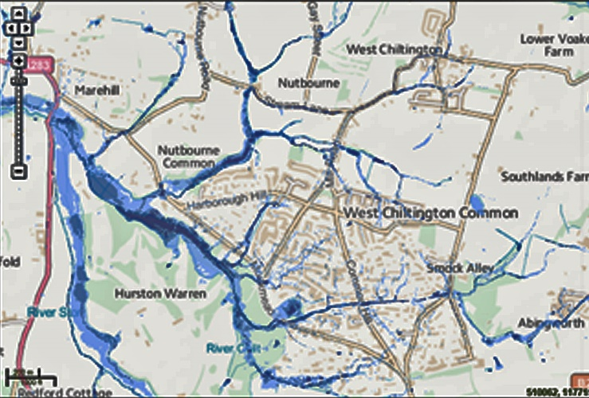
Fig 3 Environment Agency Surface Water Flood Risk Map

The Horsham Strategic Flood Risk Assessment 2010 identifies virtually the whole of the settlements as within Flood Zone 1 i.e. at low risk of flooding with just 1.14 acres (0.44%) in Flood Zone 2 i.e. at moderate risk of flooding. Surface water flooding is the principal issue at several points in the parish.

Human population

The Office for National Statistics Census Data provides information on population and the following chart illustrates the situation in West Chiltington

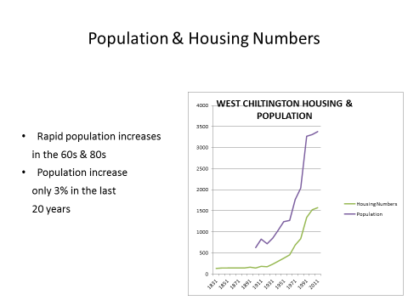

Life expectancy in Chanctonbury Ward of Horsham District Council, which includes West Chiltington, shows life expectancy at birth almost at the top of the range for the whole of West Sussex at 83 years. (Source West Sussex NHS Health Profiles 2009)

Different groups of people in the neighbourhood

The Equality Act 2010 identified a number of groups of people with protected characteristics and public bodies have a duty to show how their plans make it clear how they ensure that these groups have equal chances of accessing the services they provide. The protected groups are defined by sex, race, age, disability, religion, sexual orientation, being married or in a civil partnership, being pregnant and being transsexual.

The age profile of the parish is somewhat skewed with 40% of the population over 65 and 63% over 50. This contributes to the nature and character of the village from a social perspective and also has relevance to the type of housing that exists there. The following chart from the 2011 census shows the distribution by age.

Whilst there are no issues with most residents the infrastructure is not conducive to walking within the village as there are few pavements and the scale of the infrastructure makes it unlikely that any reasonable adjustments could be made. The potential for loneliness is, however, an issue that will be addressed in conjunction with sport and recreation and together with other local organisations and authorities.
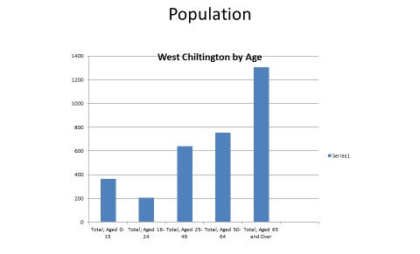
Source 2011 Census
Other data available from the Census 2011 for the parish is as follows:

Marital status | Number | Percentage
Never married | 454 | 15%
Married | 2094 | 69%
Civil Partnership | 8 | <1%
Separated | 38 | 1%
Divorced | 171 | 6%
Widowed | 263 | 9%
Total | 3028 | 100%

Disability | Number | Percentage
Limited a lot | 179 | 5%
Limited a little | 372 | 11%
Not limited | 2826 | 84%
Total | 3377 | 100%

Religion | Number | Percentage
Christian | 2360 | 70%
Buddhist | 6 | <1%
Hindu | 3 | <1%
Jewish | 6 | <1%
Muslim | 5 | <1%
Sikh | 2 | <1%
Other | 12 | <1%
None | 694 | 21%
No response | 289 | 9%
Total | 3377 | 100%

Ethnicity | Number | Percentage
White British | 2534 | 95%
Irish | 8 | <1%
Gypsy | 3 | <1%
White other | 77 | 3%
Mixed white/other | 15 | <1%
Mixed other | 2 | <1%
Asian | 17 | <1%
African | 1 | <1%
Arab | 2 | <1%
Other | 1 | <1%
Total | 2660 | 100%

Focus groups have identified only the very elderly and disabled as groups within the parish who are potentially disadvantaged.

Employment and jobs

West Chiltington is primarily a residential area with very little employment. Such business as there is small scale and much employment is part time. Most residents of working age will commute away from the area for employment.

The Office for National Statistics 2011 Census data shows 2491 usual residents aged 16 to 74 of which 293 are part time employees, 694 full time employees, 417 self-employed and 31 unemployed. The remainder are not economically active for various reasons. The largest group is 796 retired persons.

Waste management

Horsham District Council’s Acorn scheme for waste collection including garden and recyclable waste operates throughout the parish. Neighbourhood waste recycling centres at Billingshurst and Horsham are also readily accessible.

General

The baseline data has been informed by the Housing Needs Survey referred to above, a business survey and reports from 7 focus groups on issues of relevance to the parish. These are largely complete with the Housing & Built Environment Group currently completing its work on site identification and assessment with sustainability and environmental factors being identified and weighed in the balance.

Chapter 3 – Key Sustainability Issues (Task A3)

The baseline data, together with the requirements of the Plans, Policies and Programmes influencing the WCNP, can be drawn together to identify the key sustainability issues affecting the plan area. These sustainability issues can then serve as a basis for assessing the impacts of emerging policies and proposals in the WCNP, by examining the impact a policy or proposal would have on each of the key sustainability issues identified.

The process of identifying the key sustainability issues and assessment criteria was started in the development of the issues that were of interest for the Neighbourhood Development Plan. A series of key topics was identified but given the limited size of potential development estimated at approximately 30-45 homes over 20 years. A significant amount of work on measuring the current state of the natural environment had strong support in the Plan Council and the wider public and it was felt that we were well on top of environmental issues.

The key sustainability issues were identified as:

Natural Environment/ Biodiversity | The aim is to avoid development in Monkmead Woods and its SSSI and to continue to monitor the extent of biodiversity across the Parish to protect the existing environment.
Landscape | Sandwiched between the South Downs and High Weald the nature and character of the parish are strongly defined by the natural landscape.
Housing | There is limited scope for housing development given the location and the nature and character of the village. Housing need is focused on affordable homes for rent/shared equity and less expensive family homes but is constrained by high land values
Heritage | 67 listed buildings and the conservation area in the parish will need to be safeguarded
Leisure & Recreation | There is already good provision of facilities but there is a need to address provision for children and young people in the parish and to find more outlets to combat loneliness amongst the very old and disabled
Infrastructure | The road network is especially difficult with main routes affected by narrow carriageways, pinch points, single track historic sunken roads and overhanging vegetation. Limited access to high speed broadband is a constraint on business activity, working from home and leisure activity. Inadequate mobile communication taken with poor broadband constrains working from home.
Community safety | Traffic congestion in neighbouring villages and even further afield on the A27 leads to rat running and speeding which on narrow, convoluted rural roads without kerbs, pavements or street lighting is especially dangerous. There is a concern that air quality problems in Storrington will lead to diversion of more traffic through the parish and there is some risk that development in the parish could add to the air quality issues in Storrington if it generates more traffic.
Access to healthcare | A major GP surgery in Pulborough cannot be readily accessed directly by public transport
Flooding |  | Surface water flooding affects already poor infrastructure and key transport routes
Transport |  | Limited availability of public transport affects those without access to cars and acts as a constraint on reducing the volume of car journeys for commuting outside the parish or bringing workers into the parish.
Mineral extraction |  | Drilling for gas has significant environmental issues but these will be dealt with by the contractor and West Sussex CC.

The SA Framework (Task A4)

The sustainability framework related to relevant sustainability issues is as follows:

Biodiversity

Avoid development in sensitive areas and to ensure that any development respects and enhances the existing biodiversity by preserving hedges, trees and wildlife corridors..

The decision making criteria will include consideration of:

1 Whether the NDP lead to the loss to biodiversity, flora or fauna as a result of development, either directly or through habitat fragmentation?

Landscape

Protect the landscape and site assessments will be aimed at ensuring that sensitive landscape is protected from development and that separation zones between settlements are maintained.

The decision making criteria will include consideration of:

2 Whether the NDP will result in any deterioration in the landscape or village scape.

Housing

The Plan objective will be to develop two or three sites with a view to providing 30-45 homes in the plan period. Of these homes 27 will be affordable.

The primary SA/SEA objective will be to meet the housing needs of the local population by making available decent and affordable housing of an appropriate size and tenure despite the constraints. In assessing this objective the decision making criteria will include consideration of:

3 Whether the Plan will improve the availability of decent, affordable housing?
4 Whether the Plan will provide a range of housing types of various sizes and tenures?
5 Whether the Plan will avoid developing sensitive areas of the natural environment?
Leisure and Recreation

To improve facilities for children and young people to reverse the adverse effects of the loss of the old youth club building and to reduce the incidence of loneliness in the very old and disabled.

The decision making criteria will include consideration of:

6 Whether the Plan will sustain and increase community facilities.

Infrastructure and Community Safety

To manage the difficult infrastructure and seek to improve public safety on the parish roads.

The decision making criteria will include consideration of:

7 Whether the NDP will avoid materially worsening the impact of the difficult infrastructure and improving community safety.

Heritage

Avoid any development in the conservation area or close to heritage sites.

The decision making criteria will include consideration of:

8 Whether the NDP succeeds in avoiding any impact on heritage assets.

Flooding

Improve areas already subject to surface water flooding and to ensure that any new development deals adequately.

The decision making criteria will include consideration of:
8 Whether the Plan avoids worsening surface water flooding

Consultation (Task A5)

Extensive consultation through focus groups and public meetings has already taken place within the parish on issues relevant to the Plan. This will continue throughout the development process and be extended to all statutory consultation agencies as part of the pre-submission stage and include the SA/SEA when finalized.
Alternative considerations

The most significant issue with alternative outcomes is the designation of sites for development ranging from making none and choosing between a few practical options out of a wider survey.

Improvements in provision of recreational and community facilities might involve choices if proposals reach a more advanced stage than they have hitherto.

Chapter 4 – Proposed next steps

The West Chiltington Neighbourhood Development Plan is now being drafted and a combined Sustainability Appraisal and Strategic Environmental Assessment will be prepared to help shape the document.

- A continuing programme of biodiversity monitoring to cover the whole of the annual cycle
- Monitoring of all proposals for development to assess any environmental impact

Habitat Regulations Assessment

Having checked the Natural England website it would appear that no sites afforded protection under the 2010 Habitats Regulations exist within the area covered by the West Chiltington Neighbourhood Plan. On this basis this scoping review should be seen as a screening application to confirm that a Habitat Regulations Assessment (HRA) is not required in respect of this plan. As part of its review of this scoping report Natural England is asked to confirm that no HRA is required in connection with this plan.

This report has been compiled by Norman Kirby, Chairman West Chiltington Neighbourhood Plan Council on behalf of West Chiltington Parish Council. Any queries can be addressed to me at 01798 813684 or norman.kirby200@gmail.com. January 2015

Sites afforded protection under the 2010 Habitats Regulations (as amended) are designated in the UK as Special Areas of Conservation (SACs), candidate Special Areas of Conservation and Special Protection Areas (SPAs). As a matter of policy the Government also applies the procedures described below to Ramsar sites and potential SPAs. These sites are generally referred to as European sites.

